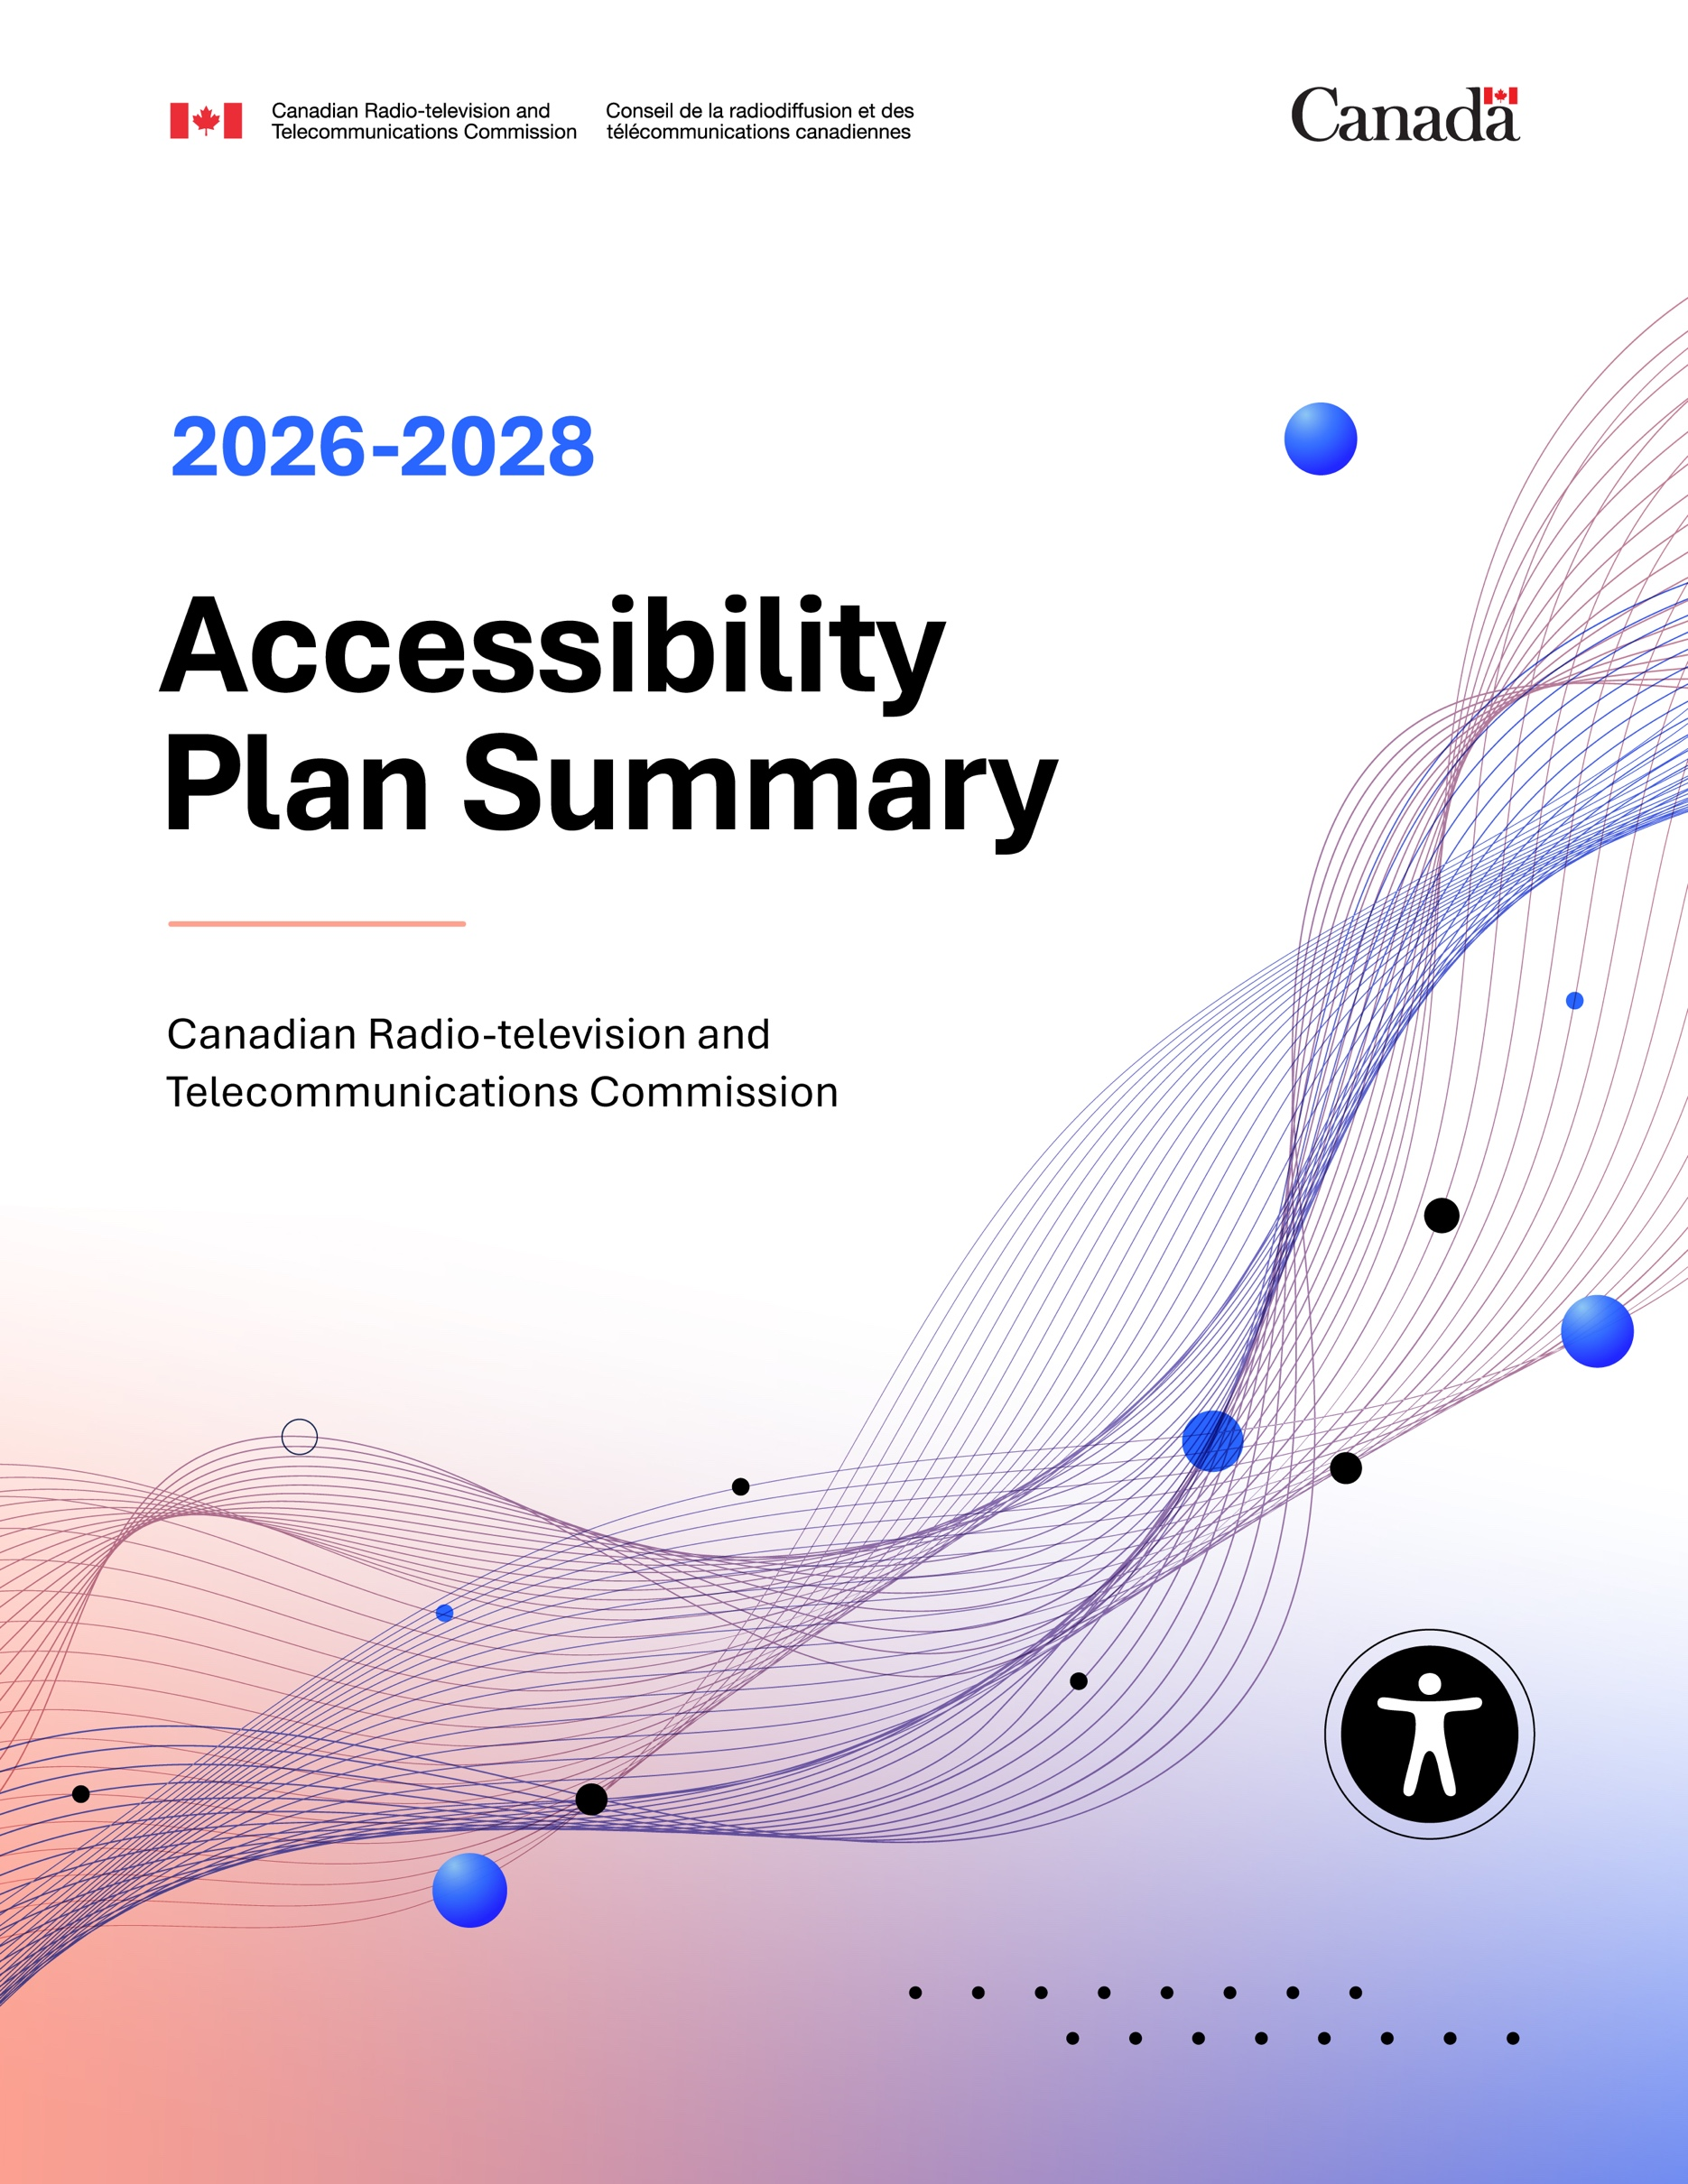

2026-2028 Accessibility Plan Summary -
Canadian Radio-television and Telecommunications Commission

ISSN 2819-8328
Catalogue number BC9-37/1E-PDF

Unless otherwise specified, you may not reproduce materials in this publication, in whole or in part, for the purposes of commercial redistribution without prior written permission from the Canadian Radio-television and Telecommunications Commission's (CRTC) copyright administrator. To obtain permission to reproduce Government of Canada materials for commercial purposes, apply for Crown Copyright Clearance by contacting:
The Canadian Radio-television and Telecommunications Commission (CRTC)
Gatineau, Quebec
Canada
K1A ON2
Tel: 819-997-0313
Toll-free: 1-877-249-2782 (in Canada only)
https://applications.crtc.gc.ca/contact/eng/library

© His Majesty the King in Right of Canada, as represented by the Canadian Radio-television and Telecommunications Commission, 2025.
Aussi disponible en français.

 | Read the full version of our 2026-2028 Accessibility Plan

The Canadian Radio-television and Telecommunications Commission (CRTC) is an independent tribunal that regulates the Canadian communications sector in the public interest. The CRTC holds public consultations and makes decisions based on the public record.
The Accessible Canada Act requires the CRTC to prepare and publish accessibility plans every three years that outline how we will identify, remove, and prevent barriers.
Putting the plan into action includes collecting feedback, consulting persons with disabilities, and publishing annual progress reports on the steps we’ve taken and what remains to be done.
We recognize that the journey to removing barriers takes sustained effort and requires us to listen, learn, and work alongside the public and our employees. Guided by the principle of the Accessibility Strategy for the Public Service of Canada, “Nothing Without Us”, we are committed to putting this plan into action in a way that respects dignity, promotes inclusion, supports informed choice, and involves persons with disabilities every step of the way.

CRTC by the numbers
740  CRTC full-time  equivalent employees |  | 2000+  broadcasters and telecommunications providers regulated
1000+  decisions published  since January 2023 |  | 10.34%  of CRTC employees self-identify as persons with disabilities*
200 000  total page views  on our website in 2024 |  | 14  Accessibility Change Agents

*As of October 1, 2025
This second CRTC Accessibility Plan builds on the work of our 2023-2025 Accessibility Plan and covers the period from October 1, 2025, to September 30, 2028. The following goals will guide the CRTC’s actions during this period:

Improving the recruitment, retention, and promotion of persons with disabilities by:
 | Developing a person-centered, individualized approach to accessibility and accommodation
 | Strengthening employment practices and training to actively promote accessibility, inclusion, and equity in the workplace
 | Supporting the recruitment, development, and promotion of persons with disabilities into management and leadership roles

Enhancing the accessibility of CRTC buildings and workspaces by:
Identifying and addressing physical and environmental barriers in workplaces and meeting spaces
Increasing the availability and access to accessibility information about CRTC workspaces and buildings
Strengthening emergency measures to ensure they are inclusive of persons with disabilities

Making information and communications technology
usable to all by:
Improving website navigation and content design to ensure critical information is easy to find, access, and understand
Advancing digital inclusion by replacing non-accessible software with alternatives that comply with latest accessibility standards
Increasing the usability of shared documents, digital content, and collaborative workspaces

Ensuring communications are accessible, inclusive, and easy to understand by:
Enhancing engagement and outreach to improve the representation and inclusion of persons with disabilities in CRTC proceedings and initiatives
Improving the accessibility of communications by simplifying processes and actively supporting the use of plain language
Maintaining active collaboration with federal accessibility partners to support shared research, innovation, and best practices

Supporting the integration of accessibility considerations into procurement processes by:
Maintaining and enforcing our contracting directive to ensure accessibility is built into all goods and services and integrated at every stage of procurement
Supporting the procurement of accessible communication services to facilitate inclusive engagement with diverse audiences

Equipping CRTC employees to design and deliver accessible services by:
Simplifying forms and processes to enhance service accessibility for persons with disabilities
Building accessibility and disability awareness among employees delivering services to the public

Improving the accessibility and inclusiveness of transportation by:
Providing employees who book travel with tools to support accessible transportation

Building an accessibility-confident CRTC by:
Raising awareness of disabilities to improve inclusion, understanding, and respect for diverse accessibility needs
Fostering a stronger sense of well-being and belonging by promoting inclusion, equity, and respect for all employees

As new accessibility standards and tools become available, the CRTC will continue to offer training and resources to support accessibility across our work. Training will focus on raising awareness of disabilities, supporting timely accommodations, strengthening digital accessibility skills, and promoting clear, inclusive communication.

Consultations
The CRTC has been engaging with persons with disabilities since the 1980s. In the 1990s, we began offering accommodations for our public consultations and made it possible to request documents in alternative formats directly through our website, reflecting our early commitment to accessibility and inclusion. To inform its 2026-2028 Accessibility Plan, the CRTC held internal and external consultations.
Internally, we received accessibility feedback from employees via our new CRTC Accessibility Network, our Accessibility Change Agents as well as the 2024 Public Service Employee Survey.
In 2025, the CRTC Accessibility Network launched with 25 members, including employees with disabilities and accessibility allies. The network serves as a safe, inclusive, and collaborative space for open dialogue on accessibility challenges, solutions, and best practices within the CRTC.
The CRTC also named 14 Accessibility Change Agents to engage employees and managers in meaningful conversations about accessibility in their sector. Through their efforts, 48 areas for improvement were identified, including opportunities to enhance hiring practices, upgrade physical workspaces, improve digital accessibility, and strengthen inclusive practices.
In the 2024 Public Service Employee Survey, many employees with disabilities reported opportunities for the organization to have more accessible tools, to clarify promotion pathways and to strengthen its recourse processes to minimize fear of reprisal. Additionally, they also reported high resilience, strong team support, and pride in their work.
Externally, the CRTC received input on its accessibility practices from many different individuals and organizations through an engagement platform called CRTC Conversations. This helped us better understand accessibility experiences: 38% of participants shared that they had encountered barriers when interacting with the CRTC over the past year. The feedback highlighted valuable opportunities to simplify processes such as completing forms, submitting information, and navigating the administrative steps of public proceedings. Participants also pointed to ways we can strengthen communication by improving document accessibility and using clearer, plain language.
The CRTC Accessibility Hub had over 950 visits in 2024, with visitors most interested in our accessibility plan and progress reports, sign language content, and regulations information. Participants called for improved navigation and more content on legal obligations.
Insights from past CRTC consultations, along with feedback received, survey data, and resources, like those from the Centre of Expertise at Accessible Standards Canada and the Canadian Human Rights Commission, all informed our 2026-2028 Accessibility Plan.

Looking ahead
The CRTC will continue building on the foundation set by the Accessible Canada Act and its corresponding regulations to ensure accessibility is integrated into everything we do, and that our efforts remain guided by the public service values of integrity, respect, and excellence.
We will also continue to:
- Learn, by collecting and considering the perspectives and experiences of persons with disabilities through our consultations and feedback process;
- Act, by tracking and addressing barriers identified in this plan and new barriers identified through ongoing engagement; and
- Report, by sharing transparent updates through our yearly accessibility progress reports.
You can contribute to this effort at any time by taking part in our consultations or sharing your input through our Accessibility Feedback Process, where you can contact us by mail, telephone, TTY, email, online webform, or live chat.
For additional information about accessibility initiatives at the CRTC, please visit our Accessibility Hub. You are also invited to subscribe to our newsletter to receive updates on accessibility-related news, resources, and initiatives.

