Electronically via GCKey

December 20, 2024

Mr. Marc Morin
Secretary General
Canadian Radio-television and
Telecommunications Commission
Ottawa, Ontario K1A 0N2

Dear Mr. Morin:
Re: Application No. 2021-0228-4 – Follow-up to Broadcasting Decision CRTC 2022-76 – Discoverability of Canadian Online Distribution Applications (6th Report)

I. INTRODUCTION
- Rogers Communications Inc. (Rogers) is filing this letter on behalf of Rogers Communications Canada Inc. (RCCI) in accordance with the directions issued by the Commission in Broadcasting Decision CRTC 2022-76 (Decision 2022-76).
- Specifically, in Appendix 2 of Decision 2022-76, the Commission issued the following direction:
The Commission directs the licensee to submit a plan within three months of the date of this decision detailing how it intends to ensure the discoverability of Canadian online distribution applications, as well as to report every six months thereafter on which applications it is carrying and how their discoverability is ensured for the duration of Rogers Communications Inc.’s broadcasting distribution undertaking licence term. This report will be published on the Commission’s website.
- With our industry-leading Xfinity TV and Xfinity Streaming platforms, RCCI provides Canadians with unique ways to discover new content, including Canadian programming, through our investments in advanced consumer-focused technologies. The Xfinity TV and Streaming platforms enhance the discoverability of Canadian content and programming services (including online applications) via an integrated user interface. Program search results and recommendations present content options from all available linear, on-demand and app services available on the platform. As a result, Canadian linear and online options are presented alongside programming provided by foreign linear and online services.
- As we have noted previously, on April 3, 2023, RCCI completed the transaction to acquire Shaw Communications Inc. (Shaw). Appendix A provides the full list of Canadian and foreign applications currently offered by RCCI on the Xfinity TV and Xfinity Streaming platforms. In most cases, these platforms host the same Canadian and foreign applications across all RCCI’s terrestrial BDUs.
- This status report adds to the information previously filed in RCCI’s first five reports, including updates on our promotional activity over the past six months. In addition, during this period, RCCI launched the foreign-owned AMC+ and Pluto TV apps nationally on both the Xfinity TV and Streaming platforms. We also launched the CityTV+ Canadian app on Xfinity TV nationally.
- RCCI continues to actively promote the availability of Canadian linear services, apps and individual programs on the Xfinity TV and Streaming platforms in our Eastern and Western BDUs through a variety of merchandising techniques. RCCI’s current features and future plans supporting the discoverability of the online Canadian applications hosted on these platforms are detailed below. In addition, as discussed during the proceeding that led to the issuance of BD 2022-76, RCCI is prepared to launch Canadian applications or free ad-supported TV (FAST) channels as they become available. We are committed to do this subject to reasonable and fair market terms to be established through negotiations.

II. FEATURES AND FUTURE PLANS

- Platforms
- The Xfinity TV and Streaming platforms are based on proprietary IPTV technology developed by Comcast. We ensure the discoverability of Canadian applications by featuring these services on the Apps homepage of the user interface for both the Xfinity TV and Streaming distribution platforms. They are presented alongside foreign online applications under the following headings: Featured, Entertainment (Free with Ads), Entertainment (Subscription), Music & Podcasts, News & Sports, Daily Life and Games. Consumers can easily launch each application by navigating to the Apps homepage and selecting the application’s tile or by speaking the name of the application into the microphone of the Voice Remote.
- Both platforms identify and promote relevant content available from hosted online applications. They recommend TV programs and movies based on the viewing habits of other customers accessing the same or similar content. Using metadata (see the next section), the Xfinity TV and Streaming platforms present “pages” to promote a given program or movie offered by the online service. These pages include features like: links to actor profiles (including other movies and/or programs featuring that actor), “people also watched” (a list of the top programs viewed by those customers who watched a given title) and “more from this app” (highlighted programs/movies identified by the app providers). These “page” options enable customers to easily browse and select similar content. See Appendix B for: a) the actor page for Catherine O’Hara (available through the Schitt’s Creek page), listing other programs and movies she has starred in; and b) how the platforms display, for a given program (Still Standing), other programs selected by viewers of that program, as well as other programs offered by that service provider (CBC).

- Metadata and Integrated Content Search
- A critical element in ensuring the relevance of the search and recommendation features presented by RCCI is searchable content metadata. Metadata consists of a variety of data fields that are used to describe a given program. Some of these fields are technical in nature (e.g., picture resolution, duration, language). Other fields support the discoverability of a program or movie (e.g., title, genre, actor/actress). These fields are used by the Xfinity search and recommendation engine to ensure results are presented “in front” of an application’s walled garden. In other words, an RCCI customer would be presented with these results from an application (e.g., programs on Stingray Qello) even if the customer does not currently subscribe to that application.
- RCCI works with application providers and Comcast to include metadata when an app is being designed and its content is added for integration into our Xfinity TV and Streaming platforms. Such integration options are detailed in the Comcast App portal and developer documentation.
- RCCI also supports Canadian programmers who wish to offer programming online but do not currently offer an application or are unable to develop one that would be compliant with Comcast’s platforms at this time. In this situation, we can work with the programmer to develop a localized application hosted on the Xfinity TV and Streaming platforms. This version of an application uses the native media player resident on each platform’s user interface to access and playback the programmer’s online content. The content offered through the app is first ingested on to RCCI’s on-demand video servers to facilitate the delivery of programming over the Internet once selected by the customer. For example, the Hollywood Suite application that is offered on the Streaming platform is not a native application. Instead, we have developed and promoted it as an “app-like” experience, using the media player on the Streaming STB, that is indistinguishable from what is offered by other hosted apps.

- Content Promotional Campaigns
- RCCI works with our content partners to aggregate and promote content around key themes or events. Relevant examples would include Truth and Reconciliation in September and the Spooky Central collection in October. In each of these instances, RCCI engages with application providers to identify the ideal program/movie titles to include as part of the themed event (e.g., specific shows, movies or music). RCCI also promotes Canadian online content through the creation of editorial “swim lanes” (i.e., row under a given heading featuring the poster art for programs with common characteristics). For example, a swim lane of shows on the Xfinity TV user interface was used to promote Canadian content on YouTube. These events and promotional activities are effective tools in highlighting the Canadian content available through the online applications that we host on our platforms. See examples in Appendix C. .

- Direct Links
- Within the “On Demand” or “Browse” sections of the Xfinity TV and Streaming platform user interfaces are opportunities to highlight Canadian applications and/or content. The “On Demand” section features a “Canadian” genre tile, which enables customers to search for movies and TV programs that are from Canada. See Appendix C.

- Launch Promotion
- To further support the discoverability of Canadian applications, as each new Canadian application is launched, RCCI will work with the app provider to develop a promotional campaign to drive awareness and adoption of the new service on both the Xfinity TV and Streaming platforms. Such campaigns will use some or all of the following features (also see Appendix D for examples of screensavers used to promote the AMC+, CityTV+ and Pluto TV apps in December):
  - Screen Saver – after a period of user inactivity, the Xfinity TV user interface will present a rotating number of images known as “screen savers” – these can be used to promote featured content or the online apps;
  - System Notifications (in the Settings menu) – when the customer clicks the “Rogers” button, the Settings icon indicates there is a new message to read, which can be used to advise customers of a new app, channel launch or how to find the latest movie/TV program releases;
  - Graphic “Takeover” – a three- or four-panel image which “takes over” the visual within a swim lane (row) on a page of the user interface; and
  - Featured Tiles – to highlight a program/movie in the top row of the VOD menu.

- Off-Platform Marketing
- Where possible, RCCI works with our content partners to incorporate Canadian and foreign applications into our off-platform Marketing tactics. For example, we have previously sent out monthly e-mail newsletters to our entire Xfinity TV/Streaming customer base highlighting new/featured programming to watch on our platforms. We can also send out dedicated e-mails focusing on one specific app or piece of content and/or promote our hosted online apps and related programming through social media channels, where we are able to integrate content within our larger mass advertising campaigns that would cover TV, radio, and out-of-home.

- Paid Support
- In addition to the above, each Canadian app and linear service has access to a common rate card for promotional campaigns where it can use any of the merchandising techniques noted above. The same rate card applies to all app providers, whether they are Canadian or foreign. The rate card enables our content partners to work with RCCI to develop customized merchandising and promotional campaigns to build consumer awareness of applications and related content. See Appendix E for examples of a paid campaign Zoomer Media worked on with RCCI to promote Vision TV.

- FAST Channels
- As noted in Decision 2022-76, RCCI is prepared to assist independent programming undertakings in the development of applications or FAST channels for online digital distribution of independent services. We indicated that the applications or FAST channels would contribute to improving the discoverability of independent content. RCCI is prepared to connect independent programming undertakings with a developer that has expertise in the Comcast system. Subject to reaching commercial terms with the independent programming undertaking, the developer would then work with Comcast to test and launch the resulting applications or FAST channels. The applications and FAST channels would be compatible for all distributors that use the Comcast platform and as we noted during the proceeding, could easily be adapted to be compatible with other distribution platforms.

III. CONCLUSION
- With all of these measures in place, RCCI is confident that we will enhance the discoverability of Canadian online distribution applications. RCCI trusts that this letter addresses the direction issued by the Commission in Decision 2022-76. Please do not hesitate to contact the undersigned if you have any questions regarding this filing.

Sincerely,



Dean Shaikh
Senior Vice President, Regulatory
Rogers Communications Inc.

APPENDIX A

List of Applications Hosted by RCCI

Application | Ownership | Platform¹ | East/West/Both
AcornTV | Foreign | Both | East
AMC+ | Foreign | Both | Both
Amazon Music | Foreign | Both | East
Apple TV+ | Foreign | Both | Both
Blippi | Foreign | Both | West
BritBox | Foreign | Both | Both
CityNews 24/7 | Canadian | Xfinity TV | Both
CityTV+ | Canadian | Xfinity TV | Both
Cocomelon³ | Foreign | Both | West
Disney+ | Foreign | Both | Both
Fawesome Black Cinema | Foreign | Both | West
Fawesome Espanol | Foreign | Both | West
Fawesome Family | Foreign | Both | West
Fawesome.tv | Foreign | Both | Both
Fiit | Foreign | Both | Both
Filmrise | Foreign | Both | Both
Filmrise British TV | Foreign | Both | West
FitYou | Foreign | Both | West
Halloween Countdown | Canadian | Both | East
Happykids.TV | Foreign | Both | West
Hayu | Foreign | Both | Both
Holiday Countdown | Canadian | Both | East
Hollywood Suite | Canadian | Streaming | East
iComedy | Foreign | Both | West
ifood.tv | Foreign | Both | Both
NBC News | Foreign | Both | East
Netflix | Foreign | Both | Both
Paw Patrol | Foreign | Both | West
Play.Works | Canadian | Both | Both
Plex | Foreign | Both | Both
Pluto TV | Foreign | Both | Both
Prime Video | Foreign | Both | Both
PW.Kids | Foreign | Both | West
Shemaroo Bollywood | Foreign | Both | West
Shudder | Foreign | Both | East
Sportsnet+ | Canadian | Both | Both
Spotify | Foreign | Both | Both
Stack TV | Canadian | Both | East
Stingray Classica | Canadian | Streaming | East
Stingray Karaoke | Canadian | Streaming | East
Stingray Music | Canadian | Both | Both
Stingray Qello | Canadian | Streaming | East
The Weather Network | Canadian | Both | Both
Toober | Canadian | Both | Both
Toonavision | Canadian | Both | East
Triller TV³ | Foreign | Both | West
tubi | Foreign | Both | Both
TVBAnywhere North America | Foreign | Both | Both
Vevo | Foreign | Both | Both
XITE | Foreign | Both | Both
XUMO Play | Foreign | Both | Both
YouTube | Foreign | Both | Both
YouTube Kids | Foreign | Both | Both
Zone-ify | Canadian | Both | Both
Footnotes
(1) Xfinity TV (offered to BDU customers) and/or Xfinity Streaming (offered to broadband-only customers).
(2) Highlighted in yellow: applications launched since last report.
(3) Previously branded as Fite.

APPENDIX B – “Page” Views

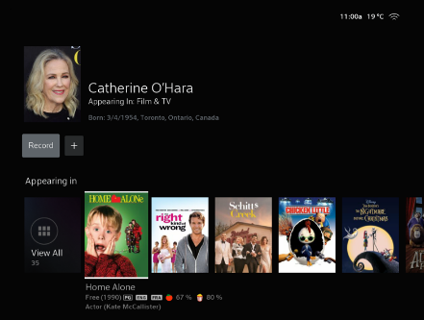

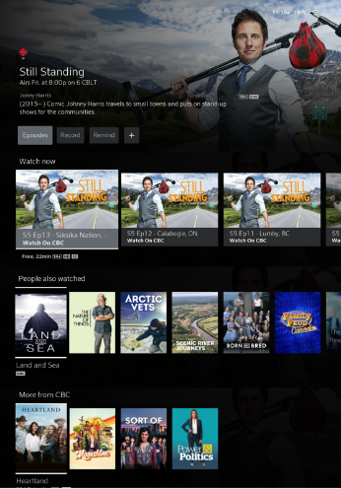
APPENDIX C
Theme / Event Pages

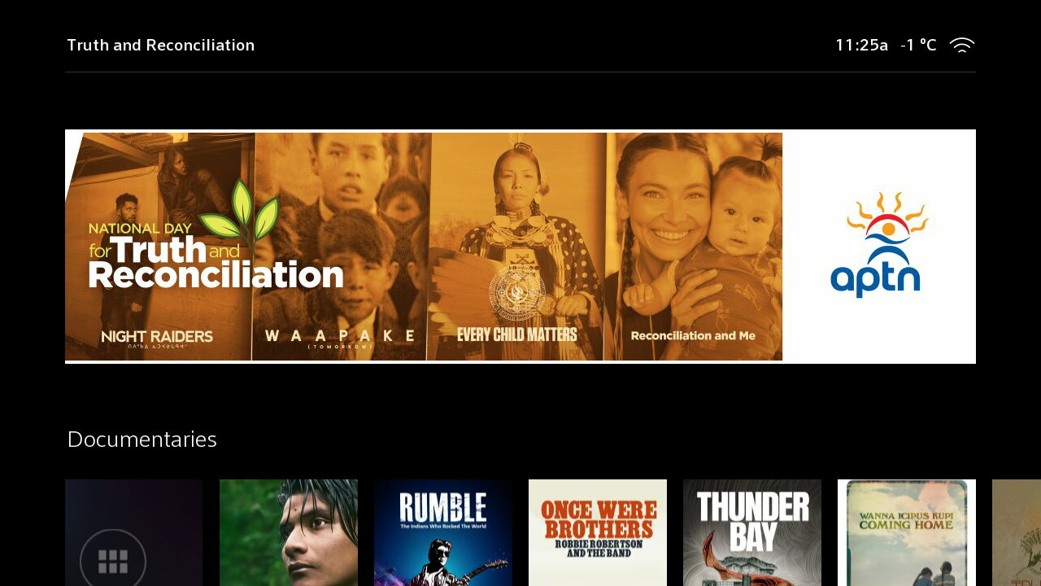

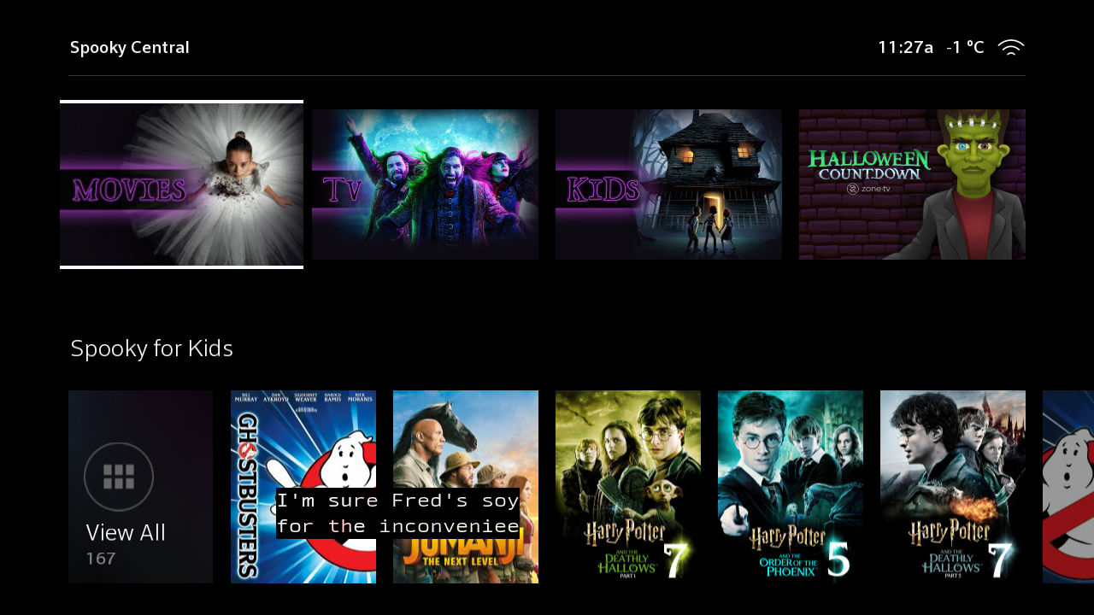

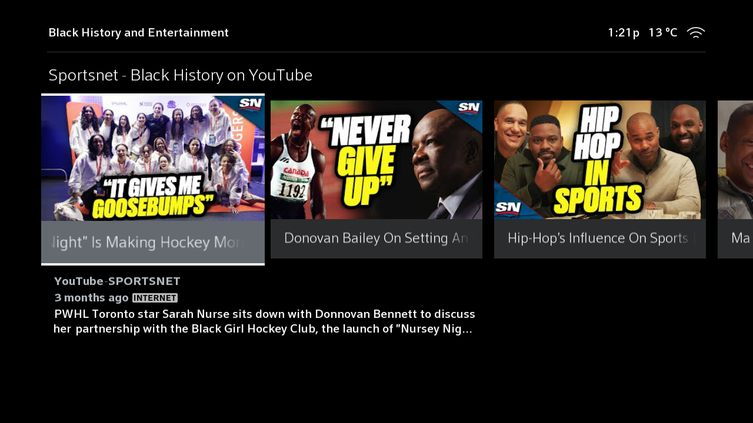

APPENDIX D
Launch Promotions/Screen Savers


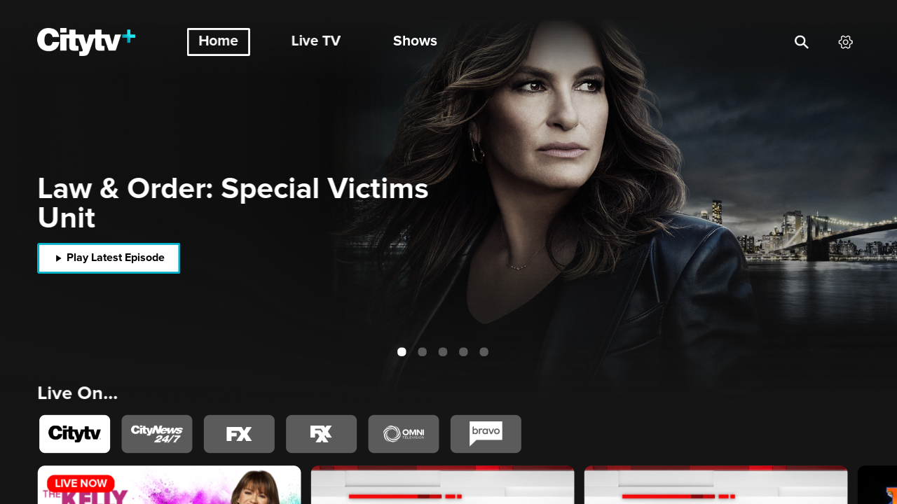
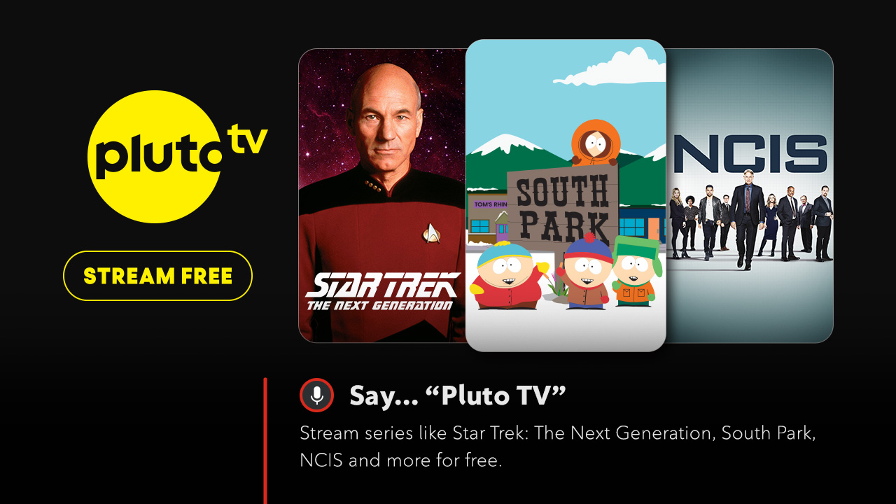

APPENDIX E

Paid Campaigns



*** End of Document ***

The Xfinity TV platform provides RCCI’s terrestrial broadcasting distribution undertaking (BDU) customers with access to: a) linear television programming channels and our licensed on-demand programming services (i.e., VOD and PPV) delivered over our closed and managed cable network; and b) Canadian and foreign online applications delivered and accessed over the public Internet. Our BDU customers can access this content through a single set-top box (STB). This service was previously marketed as Ignite TV. It was rebranded Xfinity TV on November 7, 2024.
The Xfinity Streaming platform provides Rogers’ broadband-only customers with access to Canadian and foreign online applications delivered and accessed over the public Internet. These applications are hosted on a STB that connects to the Internet via a Rogers Internet service subscription. This service was previously marketed as Ignite SmartStream and subsequently Ignite Streaming. It was rebranded Xfinity Streaming on November 7, 2024.
Following the integration of Shaw’s operations, we will now be referring to BDUs previously operated by Shaw in western Canada as the Western BDUs and those operated by RCCI prior to the transaction in eastern Canada as the Eastern BDUs.
See: https://developer.comcast.com/docs/documentation/onboarding.

